**A Just Future on the Stove: Why E-Cooking is Key to Africa's Transformation**

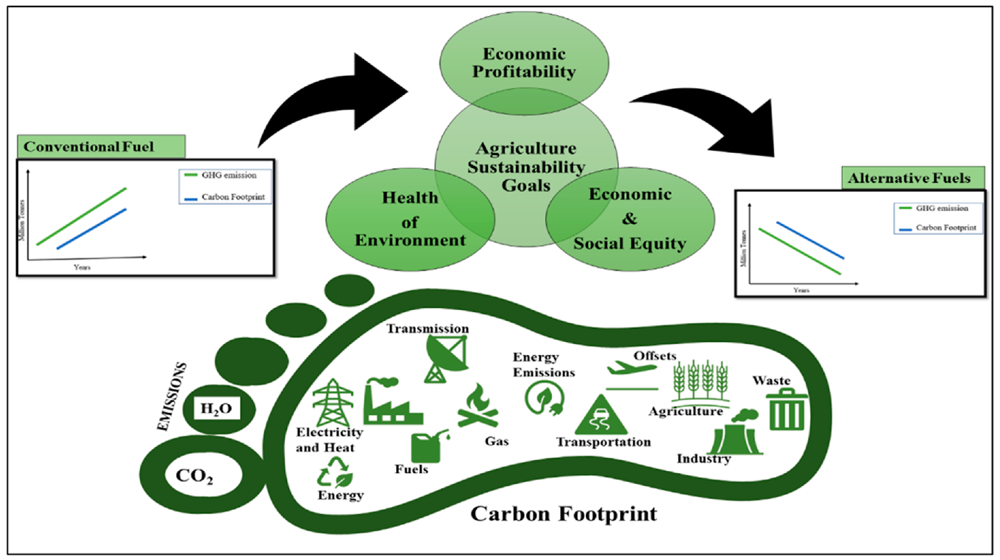

By Emily Bolo & Benjamin Oduor

Just transition is a framework that [allows the equitable sharing of sustainable](https://www.afdb.org/en/topics-and-sectors/initiatives-partnerships/climate-investment-funds-cif/just-transition-initiative) development benefits and costs so that the people’s livelihoods are supported and improved, including those of the most vulnerable, as societies shift to resilient and low-carbon economies. It affirms the rights of Africa to development and industrialization in line with the Paris Agreement negotiated equity language and the common principle through differentiated responsibilities based on different capabilities. It aims to transform the economy of nations towards environmental sustainability, climate change adaptation, decarbonization, poverty eradication, and decent work for the realization of social justice, equity, and inclusion.

Key to the developmental agenda in Africa and the basis for industrialization is energy. [The energy sector](https://reliefweb.int/report/world/issues-paper-challenges-and-opportunities-just-transition-february-2021?gclid=Cj0KCQjwk96lBhDHARIsAEKO4xbijg4XeNMYtmWrmJcvkTV0V0S7AogSWTrAxlompNxCzHiShBS7MboaAlDSEALw_wcB) is among the most crucial sectors expected to play a fundamental role in facilitating just transition and mitigation against climate change given that transition from fossil fuels is paramount in the shift towards a carbon-neutral economy. The expansion of renewables has many benefits beyond climate protection and reliable energy. Economic development will guarantee the creation of new jobs and opportunities as industries emerge. As a consequence, there is no room for inaction on matters of climate action from environmental, economic, and social standpoints. Approximately 1.2 billion jobs globally depend on natural systems and services offered by the environment. If no efforts are taken to address the climate change crisis, [10% of the total world’s economic value](https://www.weforum.org/agenda/2022/06/jobs-growth-and-social-justice-for-transformative-climate-action-a-just-transition/?DAG=3&gclid=Cj0KCQjwk96lBhDHARIsAEKO4xYMBuPr70u7WSupR9E135bjUxaez1XJyi_TQBCFXbQkQZ8_ozf_3BwaArdmEALw_wcB) will be lost. A climate investment opportunity of $29.4 trillion has been allocated to renewable energy, electric vehicles, and green buildings among others in cities in budding markets. Exclusive actions associated with renewable energy and energy efficiency are anticipated to create 18 million jobs worldwide by 2030 with clean energy access expected to profit disadvantaged rural areas.

[43% of the African population](https://www.iea.org/reports/africa-energy-outlook-2022/key-findings), approximately 600 million people, lack access to electricity. While the energy access rate in Africa is low, it is still believed to be [a major player in the worldwide energy transition](https://www.frontiersin.org/articles/10.3389/fenvs.2023.1089391/full) because of its enormous fossil fuel supply and a huge reserve of essential minerals in the production of components of renewable energy. Renewables like hydropower, geothermal, solar, and wind account for more than 80% of Africa’s new power generation capacity (**Fig 1**). Besides, 970 million Africans cook using dirty fuels. As such, if universal access to clean cooking technologies is to be achieved by 2030, 130 million people will need to shift from the use of polluting fuels every year. Though LPG appears to be the main solution for urban dwellers, constant increases in the prices of its refilling make it expensive for 30 million Africans who are consequently forced to revert to the use of biomass fuel. Such price hikes have seen countries explore alternative options such as electricity for cooking.

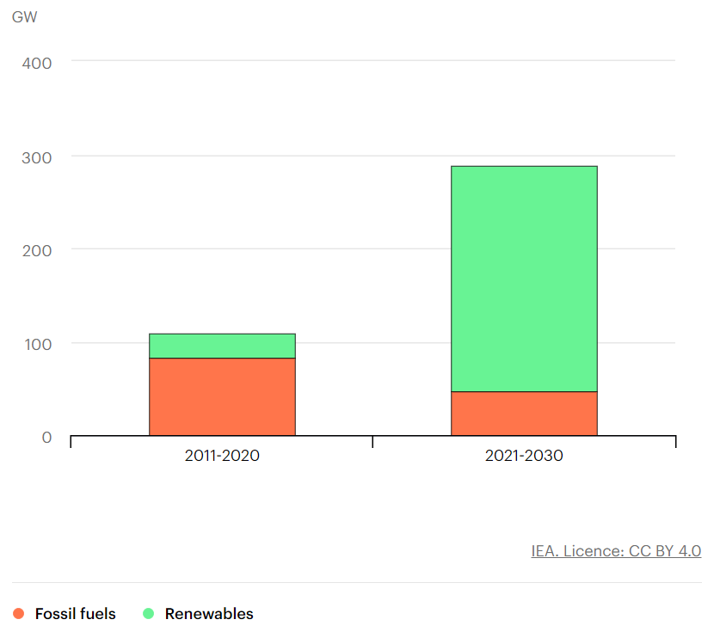

Figure 1: Power generation capacity additions in Africa in the Sustainable Africa Scenario, 2011-2030

E-cooking is gradually becoming a feasible option within urban centers in Africa as access to electricity is becoming more reliable. A rising desire for clean, efficient, and reasonably priced cooking options is growing among consumers in Africa. This increased demand is propelling the advancement and acceptance of innovative e-cooking technologies. For instance, over 70% and 40% of the population in Kenya and Uganda have electricity access. Moreover, the availability of energy-efficient cookstoves like electric pressure cookers (EPCs), induction cookers, and rice cookers is facilitating the transition. As such, should 40% of Kenyan households that are currently cooking using charcoal shift to electric cooking by 2030[, more than $600 million](https://healthpolicy-watch.news/new-e-cooking-technologies-could-reduce-climate-change-and-save-lives-from-air-pollution/) could be yielded in climate, ecosystem, and health benefits in the first 5 years of electrification for$110 million.

The prominence of e-cooking in facilitating a just transition in Africa stems from the reasons that it can address environmental, economic, and social concerns. First of all, traditional cooking techniques involving wood or charcoal combustion emit harmful pollutants capable of causing respiratory issues, heart complications, and even cancer that leads to premature deaths and disability-adjusted life years. By eradicating the need to burn wood or charcoal altogether, e-cooking holds the potential to ameliorate these health risks while simultaneously enhancing air quality. It is estimated that the adoption of modern cooking technologies in Africa could [reduce over 500,000 premature deaths](https://www.iea.org/reports/africa-energy-outlook-2022/key-findings) yearly by 2030 and [avoid 1,203 disability](https://healthpolicy-watch.news/new-e-cooking-technologies-could-reduce-climate-change-and-save-lives-from-air-pollution/)-adjusted life years (DALYs) every year.

Another pivotal aspect to consider is that conventional cooking methods contribute significantly to deforestation and climate change repercussions. However, by harnessing renewable energy sources like solar power or hydroelectricity, e-cooking presents an opportunity to curtail such detrimental environmental impacts effectively and could [save 400,000 tons/year of wood](https://healthpolicy-watch.news/new-e-cooking-technologies-could-reduce-climate-change-and-save-lives-from-air-pollution/) harvested unsustainably. Ultimately, engaging in e-cooking not only introduces healthier and cleaner alternatives but also consolidates sustainability efforts on a larger scale throughout Africa.

The just transition principle underscores leaving no one behind. Nevertheless, the overreliance on traditional cooking methods prevents women and girls from achieving their full potential as a lot of time is spent collecting firewood and cooking. Therefore, [gender dimensions should be considered as a significant](C://Users/Lenovo/Downloads/Issues%20Paper%20on%20Challenges%20and%20Opportunities%20for%20a%20Just%20Transition.pdf) component for just transition given that climate change can amplify existing vulnerabilities and result in gender-specific impacts. As such, gender has to be included as an integral aspect of the climate process since household smoke qualifies as a climate change agent. Utilizing e-cooking can prove advantageous in enhancing the economic efficiency of households. Specifically, women and girls will no longer be required to collect firewood for culinary purposes. As a result, this saves them precious time and energy that can then be dedicated to other endeavors such as education, work commitments, or childcare responsibilities. The transition would also reduce the equivalent of carbon dioxide emissions of 1[.9 million tonnes/year and save women’s time by 191 million](https://healthpolicy-watch.news/new-e-cooking-technologies-could-reduce-climate-change-and-save-lives-from-air-pollution/) tonnes/year.

The advancement towards e-cooking in Africa is currently in its initial phases, however, there is an increasing trend propelling it forward. Various factors are fueling this momentum, wherein the backing of several African governments through policies like subsidizing the cost of electric cookstoves and granting tax benefits to renewable energy corporations plays a vital role. Additionally, the private sector exhibits involvement by investing in e-cooking as well as notable companies such as Samsung, Haier, and M-Kopa have introduced electric stoves and other cooking devices into Africa's market.

In conclusion, given the significant role that e-cooking plays towards the realization of a low-carbon economy in line with the just transition concept, proper electrical infrastructure has to be installed in Africa to encourage a paradigm shift in the household cooking sector. The correct infrastructure will play a crucial role in facilitating the widespread adoption of e-cooking. Africa must consequently invest in its electricity infrastructure by expanding the power grid and enhancing the reliability of the electrical supply. Such improvements are essential in fostering the integration of e-cooking practices. Moreover, education becomes imperative as consumers require adequate knowledge about the advantages of e-cooking and how to effectively and safely utilize electric stoves. Educating individuals on proper usage will contribute significantly towards embracing this sustainable cooking method. Addressing these complex challenges is vital for accelerating the acceptance and utilization of e-cooking within African communities. By combating issues such as cost constraints, limited availability, infrastructural requirements, and disseminating relevant education materials, progress can be made regarding this important transition.

**© ARIN Press**