Flame-Free Future: Energy Efficiency and Clean Cooking Solutions for Africa
By Emily Bolo
Sub-Saharan Africa (SSA) grapples with the persistent challenge of energy poverty. Unlocking energy efficiency is key to meeting the continent's growing energy demands. While 57% of the African population has access to electricity, a mere 19% enjoy clean cooking technologies. This highlights the disproportionate reliance on traditional cooking fuels – despite constituting only 15% of the global population, Africa accounts for over 34% of global usage. This unsustainable trend necessitates urgent interventions to achieve both the Nationally Determined Contributions (NDCs) targets and Sustainable Development Goal 7 (SDG7) on affordable and clean energy.
Recognizing the gravity of the situation, world leaders pledged $2.2 billion during the 2024 Clean Cooking in Africa Summit organized by the International Energy Agency (IEA) to promote clean cooking innovations and support infrastructure. The summit culminated in the ratification of the Clean Cooking Declaration, a testament to the global commitment towards universal access to clean cooking and improved health outcomes. While this falls short of the estimated $4 billion needed, it marks a significant step forward. The annual cost of inaction in Africa due to the health impacts of climate change and household air pollution (HAP) is a staggering $330 billion. HAP ranks as the third leading risk factor for morbidity and mortality, underlining that clean cooking is more than just a culinary concern – it is about human dignity and survival. As WHO Director-General, Tedros Adhanom emphasizes, cooking should be life-giving, not life-threatening. Affordable clean cooking solutions are essential for human dignity and well-being. Dr. Akinwumi Adesina, President of the African Development Bank Group, underscores the need for innovative cooking technologies to break the cycle of suffering. Studies, such as those by Byaro, demonstrate that clean cooking can significantly reduce maternal, infant, and child mortality rates. Furthermore, the International Energy Agency (IEA) projects that widespread adoption can save 200 million hectares of forests globally.
In Kenya, the rate of access to clean cooking has increased from 15% to 30% over the last decade. Clean cooking is now being considered a developmental priority in line with the Nairobi Declaration and other documents such as the 2018-2022 National Climate Change Action Plan (NCCAP) among others. To facilitate the realization of the mitigation priority on “clean, efficient and sustainable energy technologies to reduce overreliance on fossil and non-sustainable biomass fuels” as outlined in Kenya’s Updated NDC, the Ministry of Energy recently developed The Kenya National Cooking Transition Strategy (KNCTS) that is meant to guide Kenyan households on the journey towards clean cooking access. Besides, the Kenya National Electric Cooking Strategy (KNeCS) is also being developed, which is meant to bridge the gap between clean cooking access and electric access given that the country is currently producing more electricity compared to what is being consumed and enable households to acquire clean cooking appliances. According to Dr. Faith Odongo, Director of Renewable Energy – Ministry of Energy & Petroleum, energy efficiency entails more than the use of less energy to accomplish the same task; efficiency also entails time-saving and emission reduction.
Therefore, promoting energy efficiency in cooking is a crucial step for achieving sustainability and improving livelihoods, especially in regions reliant on inefficient and polluting fuels like wood, charcoal, or kerosene. By advocating for the adoption of electric cooking technologies and utilizing their energy-saving benefits, policymakers, businesses, and communities can contribute to fulfilling the goal of doubling energy efficiency. This aligns with the commitments made at COP28, where countries pledged to increase the annual improvement rate from the current 2% to over 4% by 2030. While data from the IEA shows a slowdown in 2023 (from 2% to slightly above 1%) due to factors like extreme heat events, the new commitments are expected to lead to significant gains.
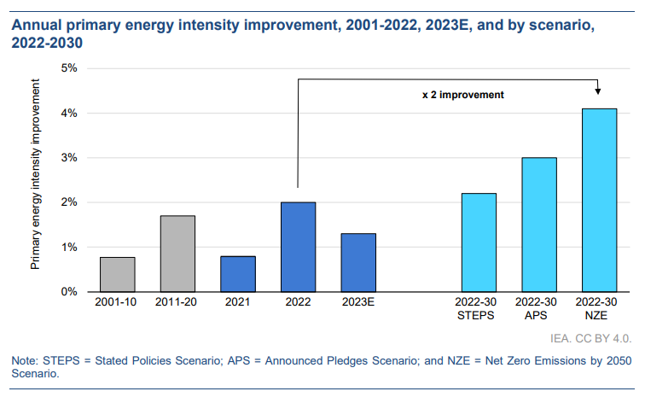
To achieve this target, governments must come up with policies that encourage energy efficiency and establish mechanisms to track implementation progress. For example, the United States and the European Union are some of the countries that made exceptional gains in energy efficiency in 2023, which ranged from 4% to 14% despite the slower global progress. The gains can be attributed to robust policy actions, increased investments, and changes in consumer behavior that resulted in spiky improvements above the global average rate. As a consequence, Governments, academia, and private sectors need to work together for greater impact to be realized. As Astrid Mozes, Danfoss President, aptly stated, "We don't want to be judged by future generations for our inaction, we want to be judged for our action." We have to stop talking about energy efficiency and move into action. Together we can create a sustainable energy future.
Cognizant of existing policy gaps that hinder effective implementation, the Kenyan government intends to address these issues through two key strategies. Firstly, they will track the implementation process of current policies and develop new ones that encourage private sector participation. Creating stable regulatory frameworks is crucial to attract these investments. Secondly, the government will take a stronger leadership role by defining clear standards for energy efficiency. This will guide the private sector in producing appliances that meet government expectations. The African Energy Efficiency Programme offers valuable resources to support these efforts. Additionally, several actions can significantly contribute to achieving the COP28 commitments. These include:

- Reduction of importation cost
- Lowering the cost of power
- Encouraging local production of energy-efficient appliances
- Increasing the supply chain
- Giving a timeline to ban the use of energy-inefficient appliances
- Developing policies and standards that enable energy-efficient products to get into the market
- Government awareness of energy efficiency labeling and standards
- Enabling finance flow
- Consumer behavior change

In conclusion, the urgency for widespread clean cooking adoption in Africa is undeniable. To truly make a difference, we must scale up existing initiatives and ensure they reach a vast and diverse audience. This requires a shift from exclusive conversations to a more inclusive approach. The voices of everyday people struggling with food security and inefficient cooking methods need to be heard and addressed in discussions about clean cooking solutions. Furthermore, transitioning to clean cooking necessitates a move from isolated projects to systemic programs. Sustainable change requires a comprehensive approach that addresses infrastructure, financing, education, and behavior change. By fostering collaboration between governments, the private sector, NGOs, and communities, we can develop and implement these programs effectively. The success stories highlighted in this blog, such as Kenya's National Cooking Transition Strategy, demonstrate the positive impact of such collaboration. By scaling up these solutions and learning from best practices across Africa, we can create a brighter future for the continent.
The 2024 Clean Cooking in Africa Summit and IEA 9th Annual Global Conference on Energy Efficiency provided valuable insights some of which have been included in this blog. However, the real work lies in implementation. Governments must translate these pledges into concrete policies that incentivize energy efficiency and clean cooking adoption. Additionally, continued investment in research and development is crucial for creating ever-more affordable and efficient clean cooking technologies.

©ARIN Press

